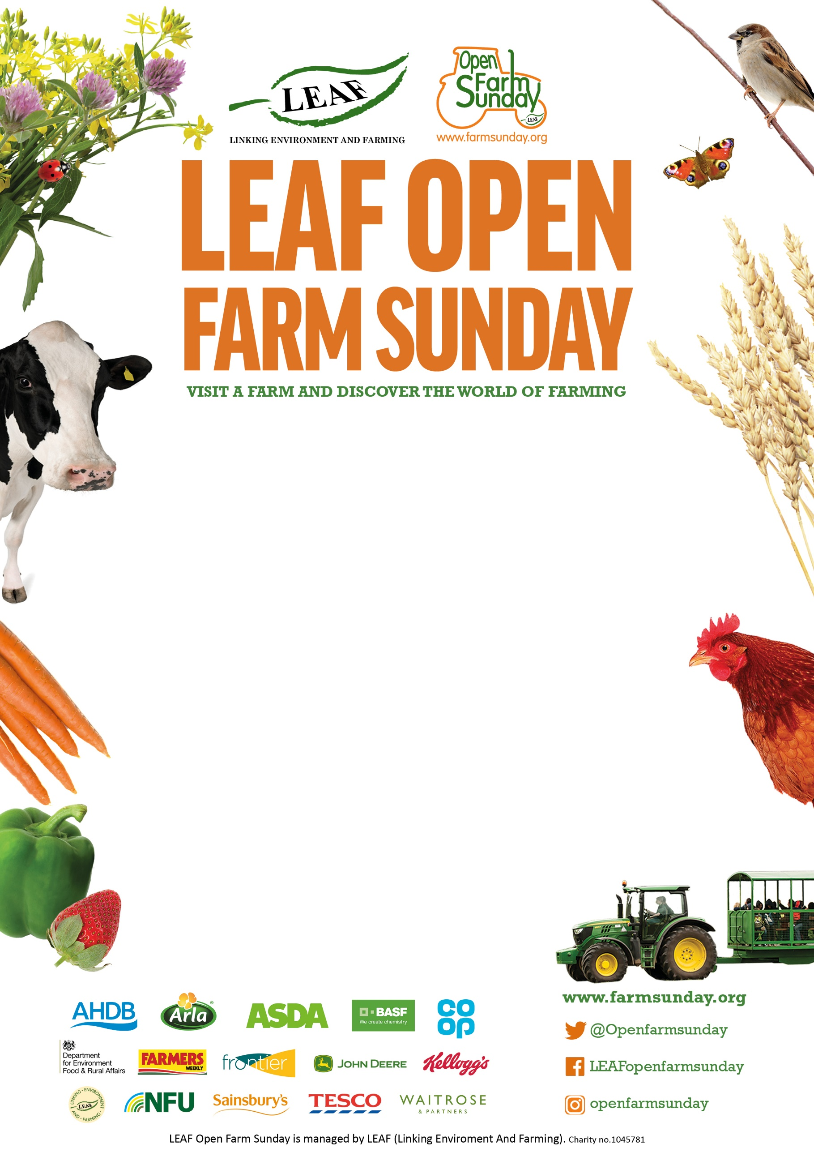

**The Allerton Project,**

**Allerton Visitor Centre,** Loddington, Leicestershire, LE7 9XE  
**11th June**

**10.30 AM – 3.30 PM**

**Tractor rides** from 10.30am onwards, refreshments available from Launde Farm Foods and **Cream Teas** from the Loddington WI.

There will be a range of activities appropriate for all of the family. **Come and learn about sustainable food and farming in the British Countryside**

**Book tickets here**https://www.eventbrite.com/e/leaf-open-farm-sunday-tickets-640517975507